Sensitivity Testing

Varying the acceleration

(while keeping the following the same: ticks=500, grid-size-x = 3, grid-size-y = 3, num-cars = 50, power? = true, ticks-per-cycle = 20, speed-limit = 1, current-auto? = true, current-phase = 0%)

Test 1 (acceleration = 0.099)

Test 2 (acceleration = 0.0891) - 10%

Test 3 (acceleration = 0.0792) – 20%

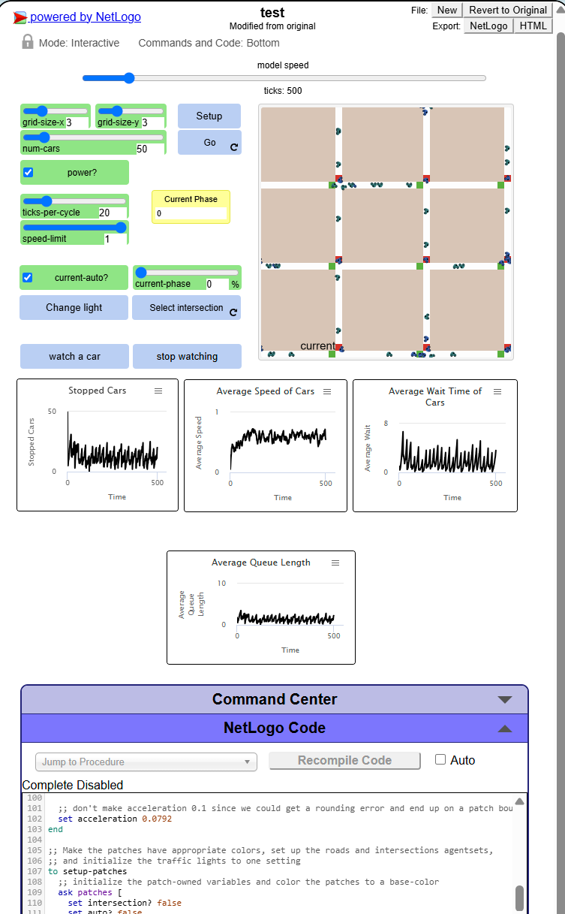

Test 4 (acceleration = 0.1089) + 10%

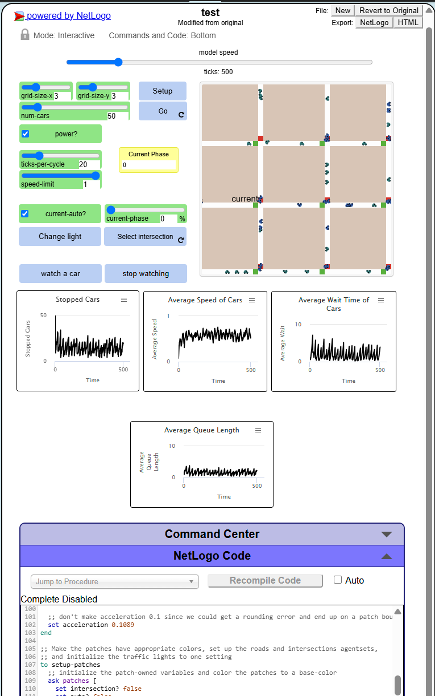

Test 5 (acceleration = 0.1188) + 20%

